Integrated Science: Physics Practice Test

Short Calculation:

1. If it takes 3 hours to drive a distance of 192km on a motorway, what would be your average speed in km/h?
2. What is your average speed in km/h if you travel 15km in 2 hours and 30 minutes?
3. John decided to cycle to his friend’s house at a speed of 5.5km/h and the journey took 2.5 hours. How far did John cycle?
4. Sally runs at a pace of 8km/h. If she ran for a period of 4.5 hours, how far has she travelled?
5. If you were travelling at 32km per hour, how long would it take to travel a distance of 70km?
6. The distance between two cities is 144km, it takes 3 hours to travel between these cities. What speed is the person travelling at?
7. The distance-time graph shows class 8A’s journey to the zoo. They stopped for a picnic on the way to the zoo.

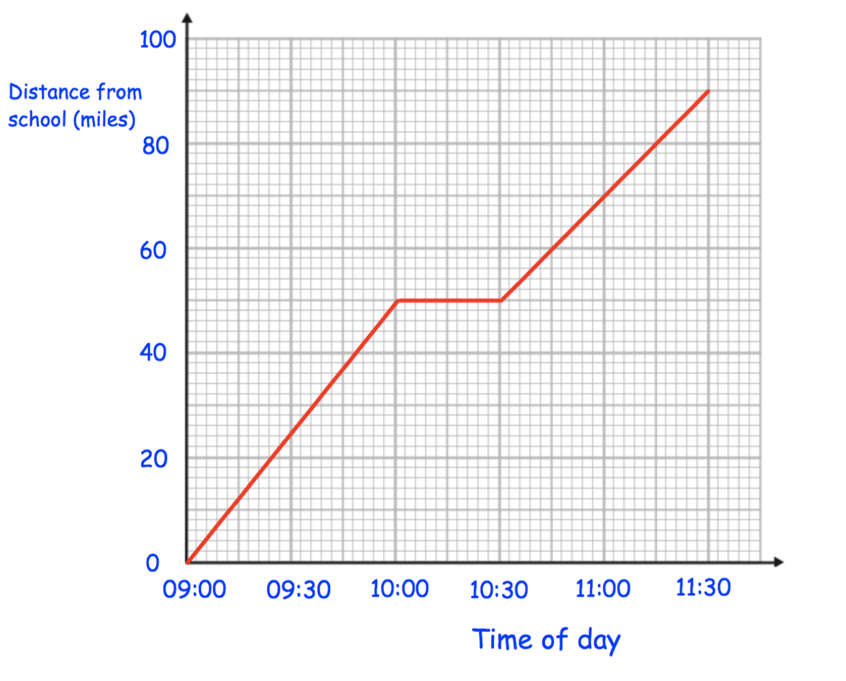

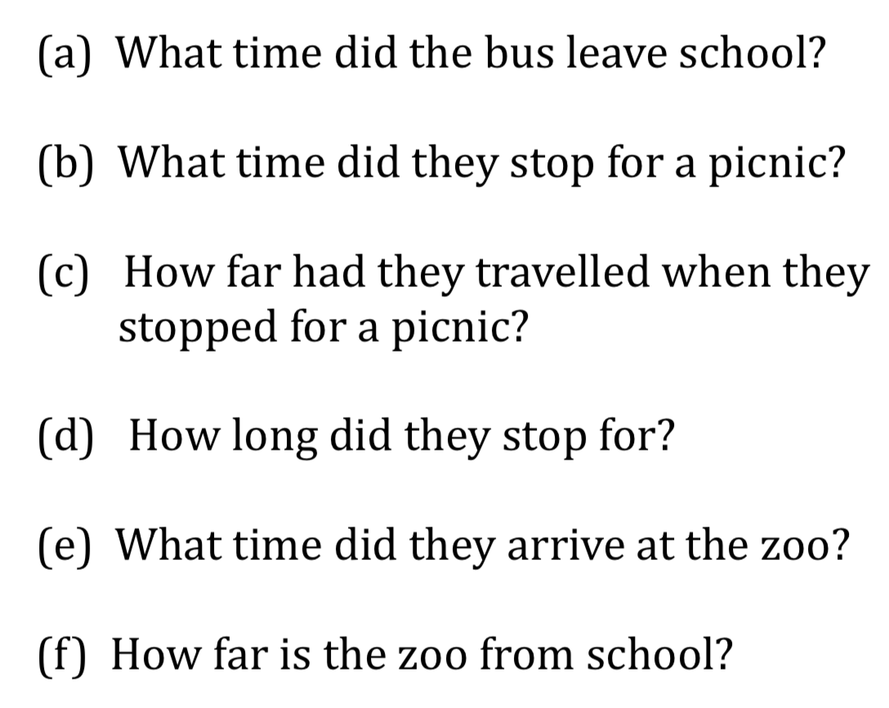

1. Emma travelled to her Grandmother’s house and back.  
   The distance-time graph shows information about her journey.

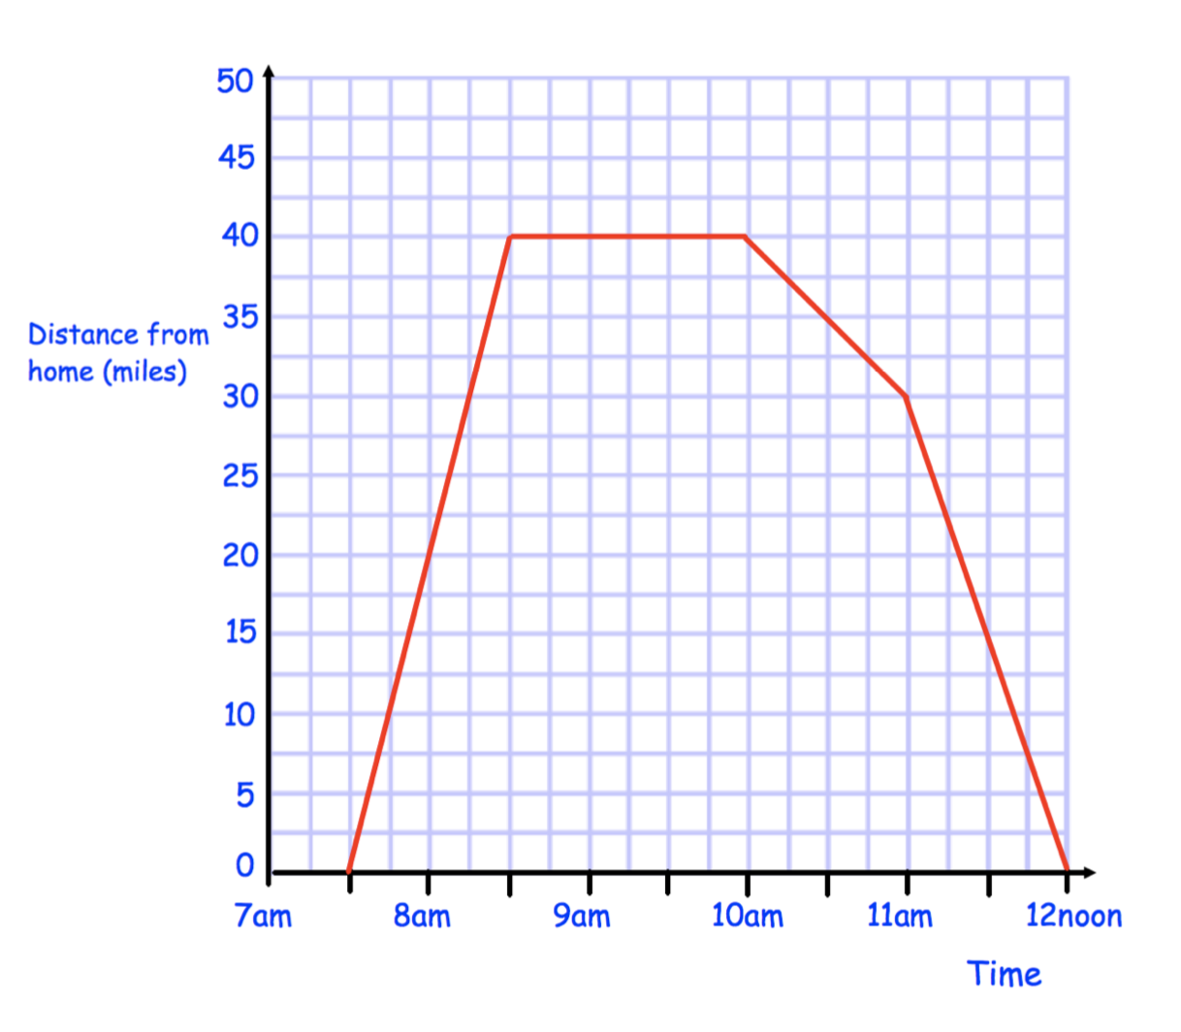

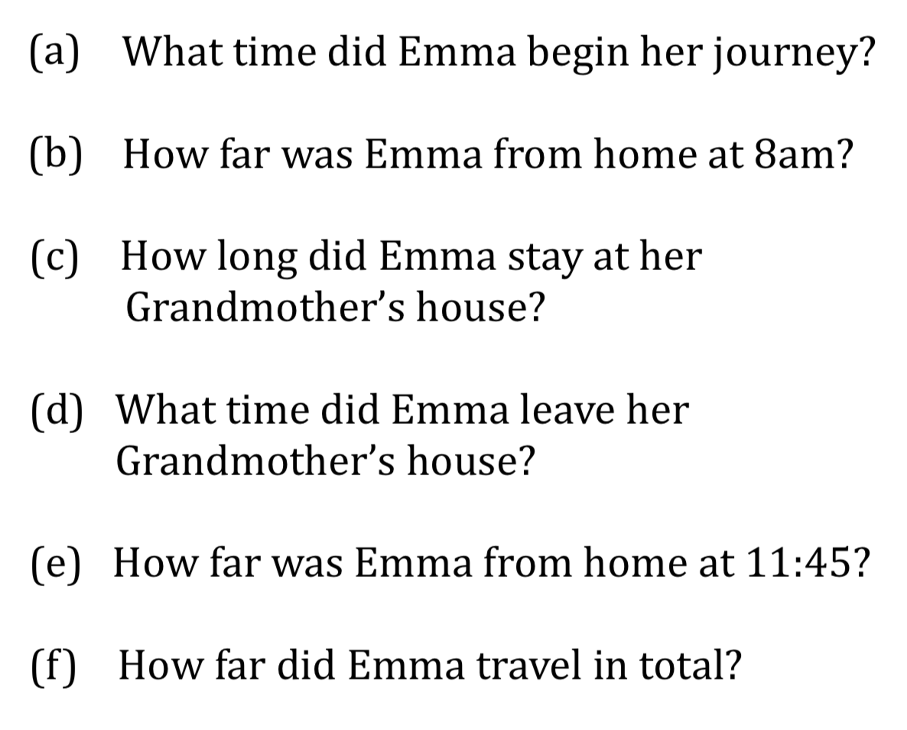

1. Erin leaves home at 11am. She cycles at a speed of 16 miles per hour for 90 minutes. She stops for half an hour. Erin then cycles home and arrives at 3pm.
   1. Draw a distance-time graph to show Erin’s journey.
   2. What is Erin’s average speed on the return part of her cycle?



1. Thomas leaves home at 14:00. He drives at an average speed of 40kph for 3 ½ hours. Thomas stops for 30 minutes. He then drives home at an average speed of 70kph.
   1. Draw a distance-time graph to show Thomas’s journey



1. Match the motion graph with the correct description below, then justify your choice.

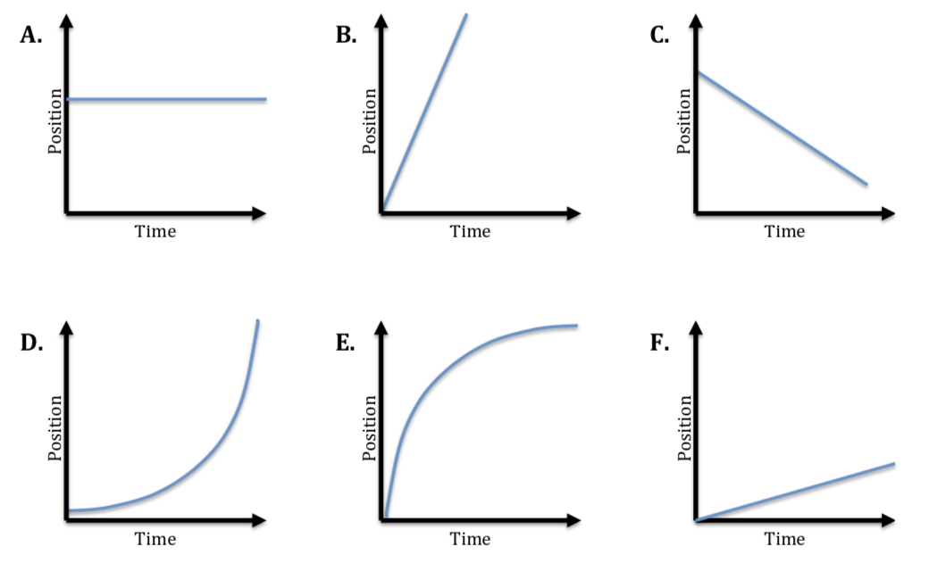

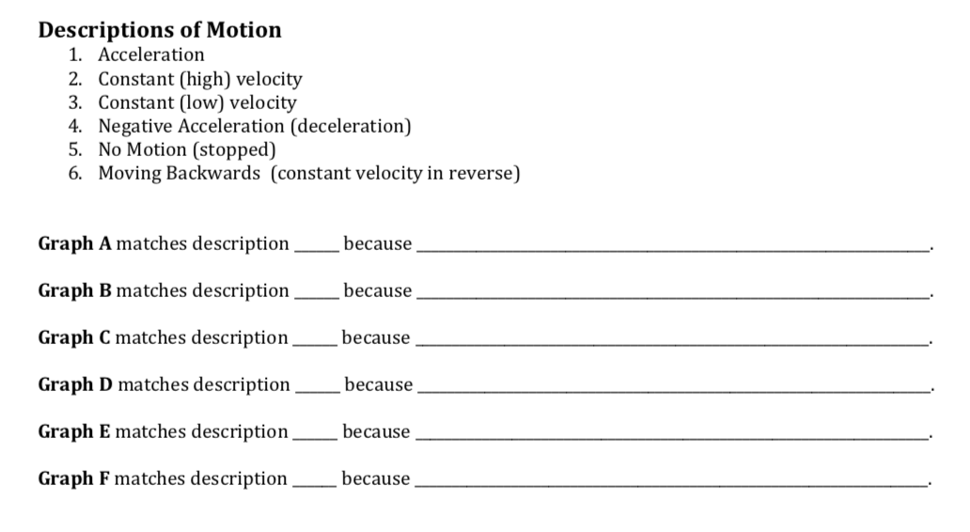

1. The tickertape below was attached to the back of a toy car which then rolled down a ramp.
   1. Using your pen/pencil, draw an arrow showing the direction the car travelled relative to the tickertape.



* 1. Calculate the acceleration of the car from the tickertape shown above. The time between each tick is 0.02 seconds.

1. Energy can be broadly categorised into the following two groups, kinetic and potential.
   1. Arrange the types of energy below under their correct heading.

* Nuclear
* Thermal
* Sound
* Chemical
* Elastic
* Motion
* Light
* Gravitational
* Electrical
  1. Provide two examples of elastic energy, explaining how each example of elastic energy supports your decision on whether to place it under the kinetic or potential energy heading.